**Exploring the iris data set Using R**

data(iris)

str(iris)

### Scatter plot 🡪

plot(iris$Sepal.Length, type = 'l')

plot(iris$Sepal.Length, type = 'p')

plot(iris$Sepal.Length, type = 'o')

plot(iris$Sepal.Length, iris$Sepal.Width, type = 'p')

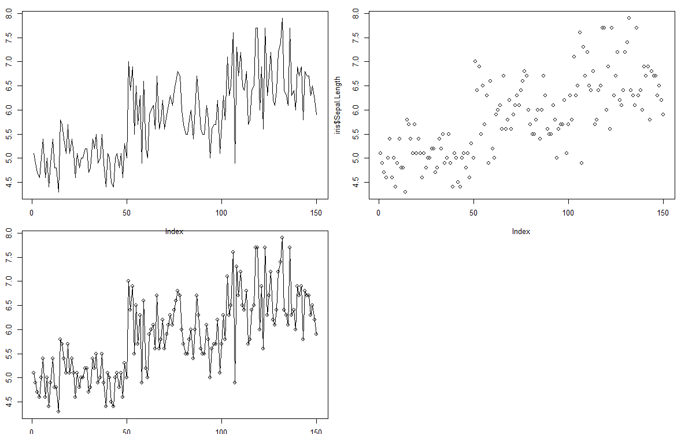

### Titles and axis labels 🡪

plot(iris$Petal.Length, iris$Petal.Width, main = "Edgar Anderson's Iris Data",

xlab = "Petal Length", ylab = "Petal Width")

plot(iris$Sepal.Length, type = 'l', lty = 2, lwd = 2,

main = "Edgar Anderson's Iris Data", xlab = "Petal Length", ylab = "Petal Width")

plot(iris$Petal.Length, iris$Petal.Width, pch = 8,

main = "Edgar Anderson's Iris Data", xlab = "Petal Length", ylab = "Petal Width")

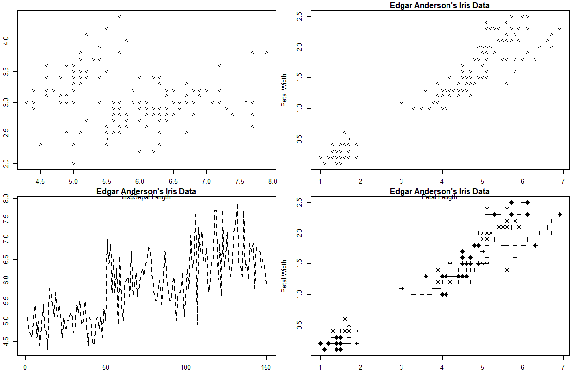

### Colors 🡪

plot(iris$Petal.Length, iris$Petal.Width, pch = 8, col = 'red',

main = "Edgar Anderson's Iris Data", xlab = "Petal Length", ylab = "Petal Width")

mycolor <- c("red","green3","blue")[as.factor(iris$Species)]

plot(iris$Petal.Length, iris$Petal.Width, pch = 8, col = mycolor,

main = "Edgar Anderson's Iris Data", xlab = "Petal Length", ylab = "Petal Width")

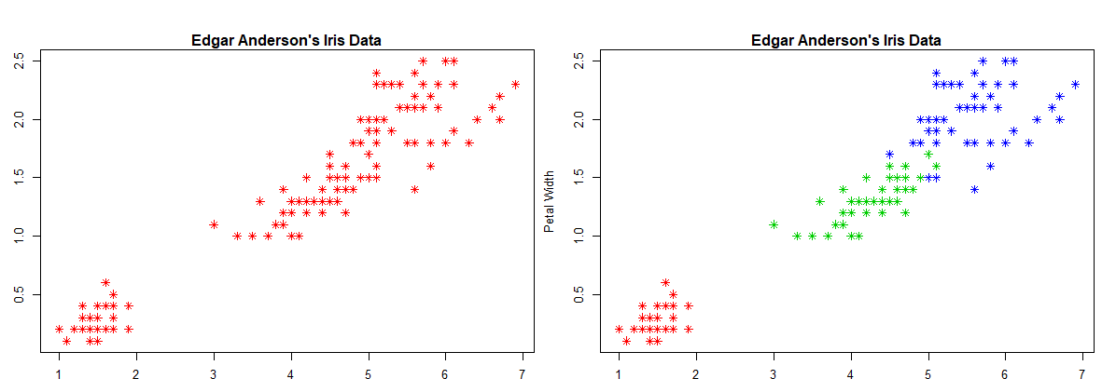

### Axes 🡪

plot(iris$Petal.Length, iris$Petal.Width, pch = 8, col = mycolor,

main = "Edgar Anderson's Iris Data", xlab = "Petal Length", ylab = "Petal Width",

xlim = c(0,10), ylim= c(0,10))

plot(iris$Petal.Length, iris$Petal.Width, pch = 8, col = mycolor,

main = "Edgar Anderson's Iris Data", xlab = "Petal Length", ylab = "Petal Width",

xlim = c(0,10), ylim= c(0,10), axes = FALSE)

axis(1, at = 1:10, lab = c(1:10))

axis(2, at = 1:10, lab = c(1:10))

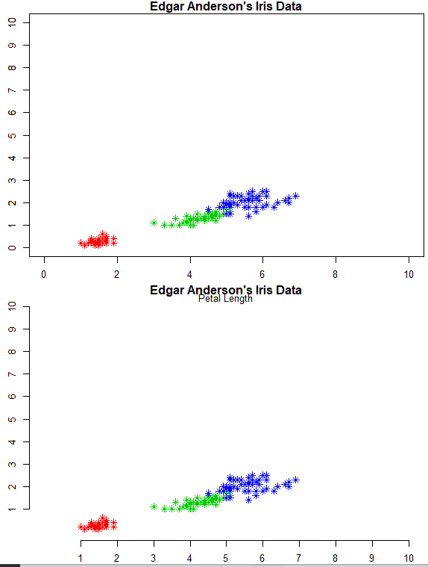

### Legend 🡪

plot(iris$Petal.Length, iris$Petal.Width, pch = 8, col = mycolor,

main = "Edgar Anderson's Iris Data", xlab = "Petal Length", ylab = "Petal Width",

xlim = c(0,10), ylim= c(0,10))

legend('topright', legend = unique(iris$Species), col = c("red","green3","blue"), pch = 8)

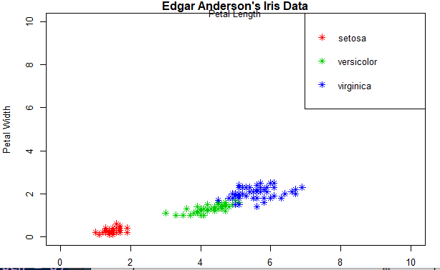

loc <- list()

loc$x <- 2.75

loc$y <- 4.94

plot(iris$Petal.Length, iris$Petal.Width, pch = 8, col = mycolor,

main = "Edgar Anderson's Iris Data", xlab = "Petal Length", ylab = "Petal Width",

xlim = c(0,10), ylim= c(0,10))

legend('topright', legend = unique(iris$Species), col = c("red","green3","blue"),

pch = 8, bty = 'n')

text(loc$x, loc$y, labels = "Hello! this is a Scatter Plot")

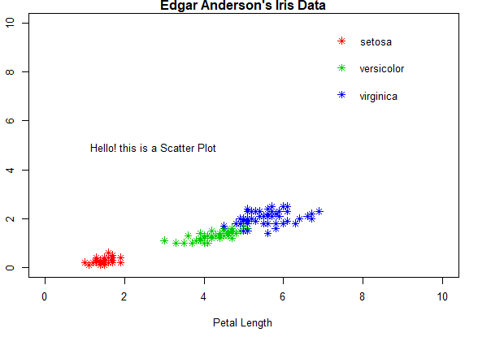

## Multiple plots 🡪

par(mfrow=c(2,2))

boxplot(iris$Sepal.Length~iris$Species, main = "Boxplot of Sepal Length",

xlab = "Species", ylab = "Sepal Length", col = c("red","green3","blue"),

cex.lab = 1.25)

hist(iris$Sepal.Length, main = "Histogram of Sepal Length",

xlab = "Sepal Length", ylab = "Frequency", col = c("grey"), cex.lab = 1.25)

plot(iris$Sepal.Length, type = 'l', lty = 2, lwd = 2, col = 'red',

main = "Variation with of Petal Width and Petal Length",

xlab = "Petal Length", ylab = "Petal Width", cex.lab = 1.25)

plot(iris$Petal.Length, iris$Petal.Width, pch = 8, col = mycolor,

main = "Scatter plot of Petal Width and Petal Length",

xlab = "Petal Length", ylab = "Petal Width", cex.lab = 1.25)

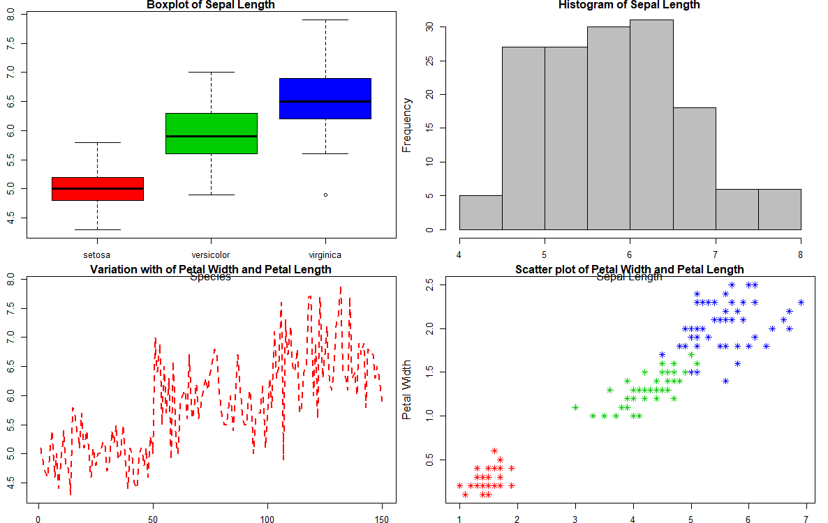

## Saving plots 🡪

pdf("theplot.pdf")

boxplot(iris$Sepal.Length~Species, main = "Boxplot of Sepal Length",

xlab = "Species", ylab = "Sepal Length", col = c("red","green3","blue"))

dev.off()

### Resources 🡪

Additional resources you may want to consult are the R demo for different types of plots: demo("graphics") and the help for plot (?plot).

## 